6 + 1 Traits of Writing

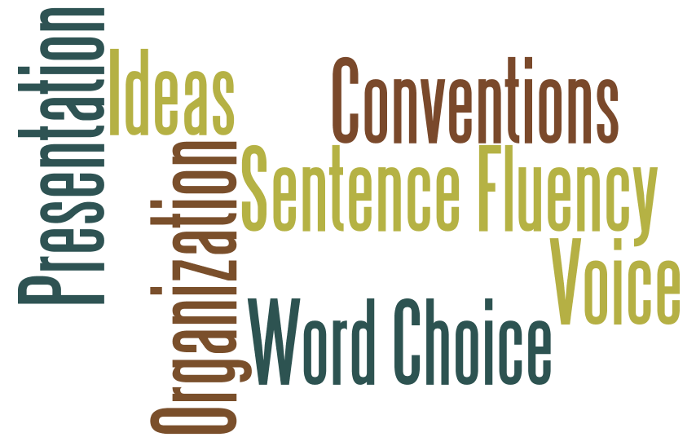

Carol Campbell
NAD Director of Elementary Education
2012

